Add a "tooltip" to the paragraph below with the text "About W3Schools".
<p title="About W3Schools">W3Schools is a web developer's site.</p>

Output:
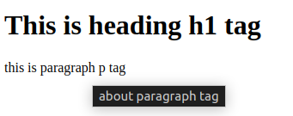

Make the element below into a link that goes to "https://www.w3schools.com".
<a href="https://www.w3schools.com">This is a link</a>

Set the size of the image to 250 pixels wide and 400 pixels tall.
<img src="w3schools.jpg" width="250" height="400">

Alternate text is useful when the image cannot be displayed, like when the page is read by a screen reader.
<img src="w3schools.png" alt="w3schools Logo">

HTML <abbr> Tag
<p>The <abbr title="World Health Organization">WHO</abbr> was founded in 1948.</p>

